**TITLE**

Design and Development of a Smart Wheelchair with Safety, Authentication, and Remote Medical Control

**AUTHORS**

Afnan Hakim bin Adinazrin ,Muhammad Taufiq bin Mukhtar ,Muhammad Danish Farhan bin Amiruddin ,Department of Mechatronics Engineering, INTERNATIONAL ISLAMIC UNIVERSITY MALAYSIA (IIUM) Email:

**ABSTRACT**

This project presents the design and implementation of a smart, safety-enhanced wheelchair system intended for individuals with lower-limb impairments. The conventional manual wheelchair is upgraded into an electrically driven system capable of four-directional movement using DC motors controlled via push buttons. A dual-controller architecture is employed, where an Arduino functions as the master controller handling user inputs, safety sensors, and vision processing, while an ESP32 operates as the slave controller responsible for motor actuation and Bluetooth communication.

An ultrasonic sensor mounted at the front of the wheelchair serves as an emergency stop mechanism, automatically halting motor operation when an obstacle is detected within 60 cm to prevent collisions. Additionally, a HuskyLens AI camera is integrated to provide face detection as an authentication layer, ensuring that only authorized users can activate the system. For enhanced safety and medical supervision, Bluetooth communication allows a doctor to remotely enable or disable the wheelchair using a mobile device, with override capability at any time.

The proposed system demonstrates effective integration of sensors, embedded controllers, wireless communication, and AI-based vision, resulting in a secure, user-friendly, and medically supervised assistive mobility solution.

## 

## **1. INTRODUCTION**

## Mobility impairment due to lower-limb disabilities significantly affects an individual’s independence and quality of life. Traditional wheelchairs, while widely used, often require physical assistance or manual effort, limiting autonomy and increasing reliance on caregivers. Electrically powered wheelchairs address some of these limitations; however, safety concerns such as collision risks, unauthorized usage, and lack of medical supervision remain critical challenges.

## Recent advancements in embedded systems, wireless communication, and artificial intelligence have enabled the development of smarter assistive technologies. Sensors such as ultrasonic distance sensors can enhance user safety through real-time obstacle detection, while AI-based vision systems allow for secure user authentication. Furthermore, Bluetooth-enabled microcontrollers enable remote monitoring and control, which is particularly beneficial in medical and rehabilitation contexts.

## This project aims to develop an intelligent wheelchair system that prioritizes safety, controlled accessibility, and system integration. The wheelchair uses DC motors for movement in four directions, activated via push buttons. An Arduino–ESP32 master-slave architecture is adopted to separate sensor processing from motor control, improving system reliability and modularity. The inclusion of an ultrasonic sensor provides an automatic emergency stop function, while HuskyLens face detection ensures only authorized users can operate the system. Additionally, Bluetooth control allows a doctor to remotely enable or disable the wheelchair, ensuring medical oversight and patient safety.

## 

## 

## **2. METHODOLOGY**

2.1 Project Development

Start with a problem statement, we find the solution for helping impaired person which are not be able to walk. We come out with smart-wheelchair project. To overview the entire system, we used block diagram to simplify. Fig 1. show the simplify version of the system by having power source as the input, and motor move is the output when it’s all controlled by the direction button. Fig 2. Is showing the combined block diagram 1 and more complicated system including the microcontroller, input and output components. Then, we create a flow chart for the system to represent working principle of the smart-wheelchair. Fig 3 is the flowchart for the whole system.



Fig 1. Block diagram for the simplify version of the system



Fig 2. shows the combined block diagram 1 and more complicated system including the microcontroller, input and output components

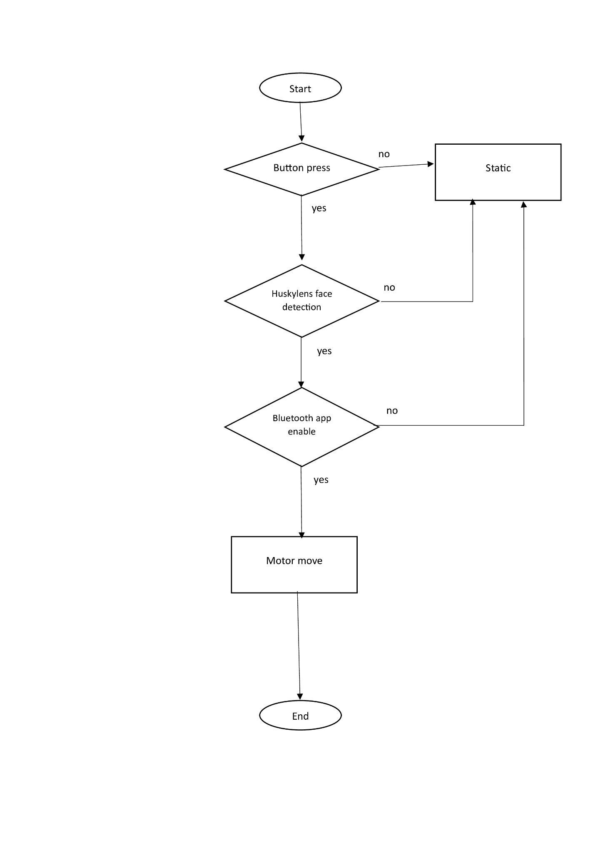

Fig 3. Flowchart for the whole system

2.2 Schematic Diagram and Prototype Setup

Fig. 4 shows the schematic wiring diagram of the smart wheelchair system. The system uses several input components, which are a HuskyLens for face detection, an ultrasonic sensor for obstacle detection, a esp32(as built in bluetooth) to enable the system, and push buttons to control the movement direction.

This project uses two microcontrollers: an Arduino and an ESP32 module. The Arduino is used as the master controller, while the ESP32 acts as the slave controller. The Arduino processes all sensor inputs and button commands. The ESP32 handles Bluetooth communication, and all Bluetooth coding is implemented in the slave controller.

The output of the system is a motor that moves the wheelchair. The motor operation depends on the input signals received and processed by the Arduino. This setup allows the wheelchair to move safely and according to user control.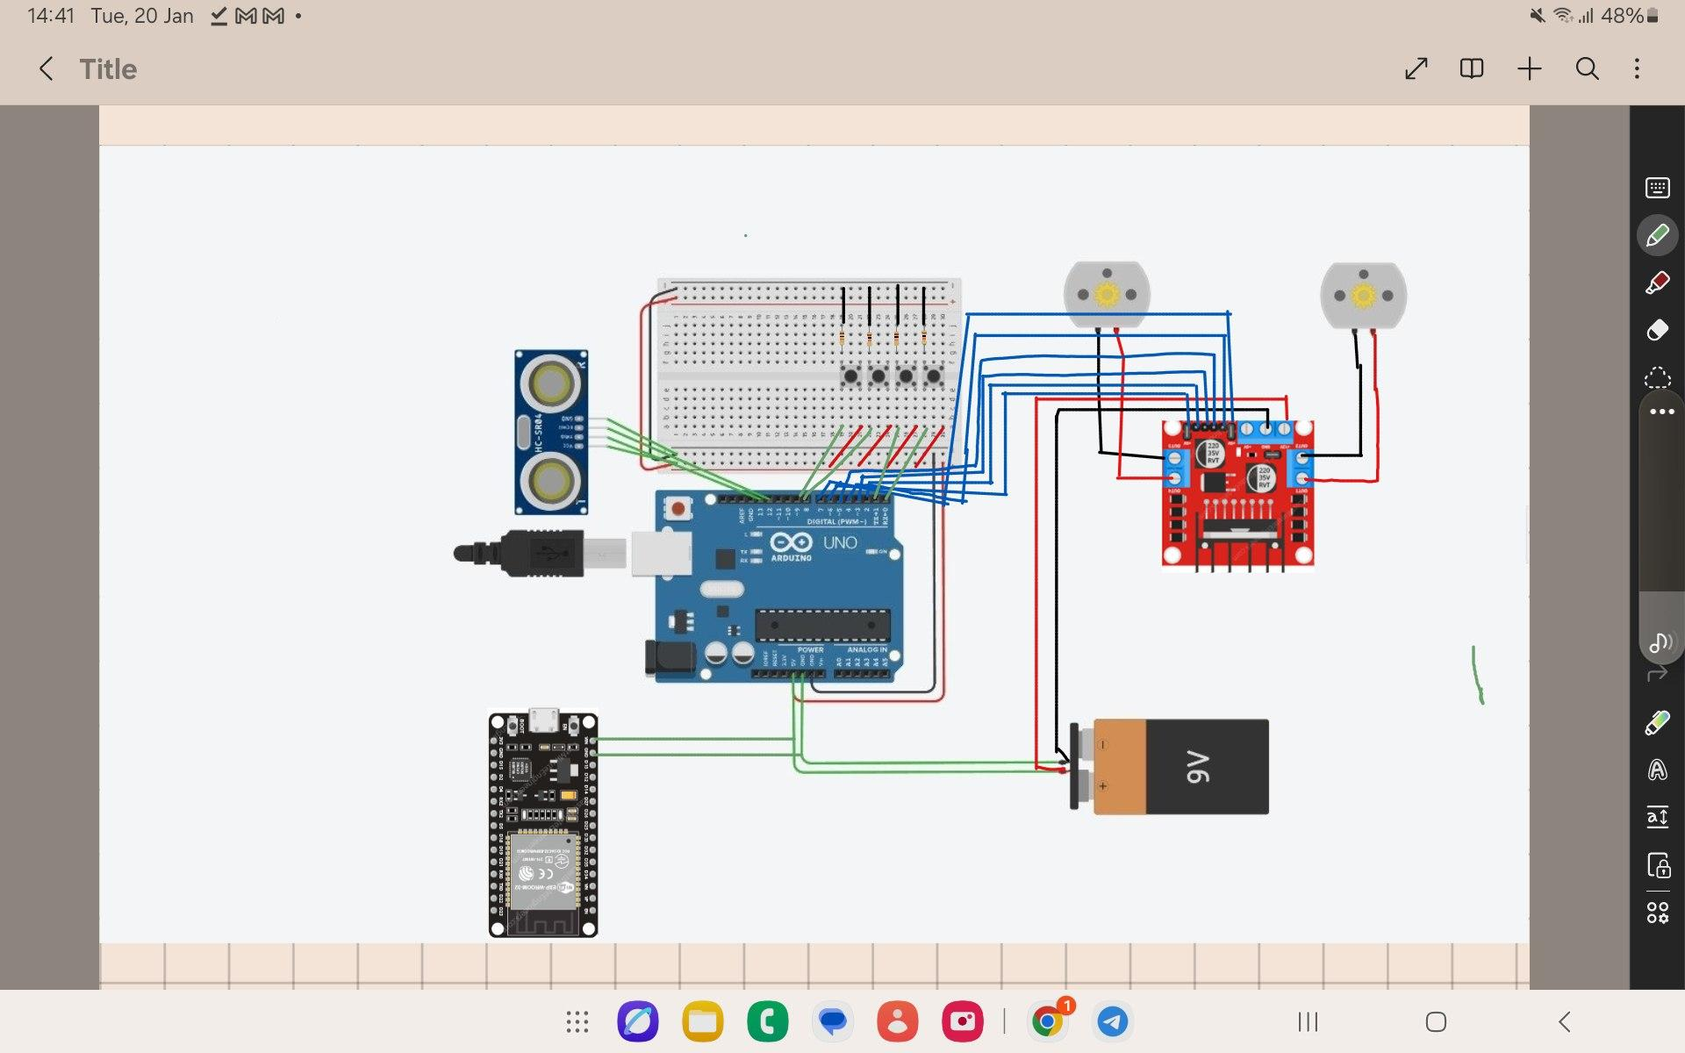

Fig. 4 shows the schematic wiring diagram of the smart wheelchair system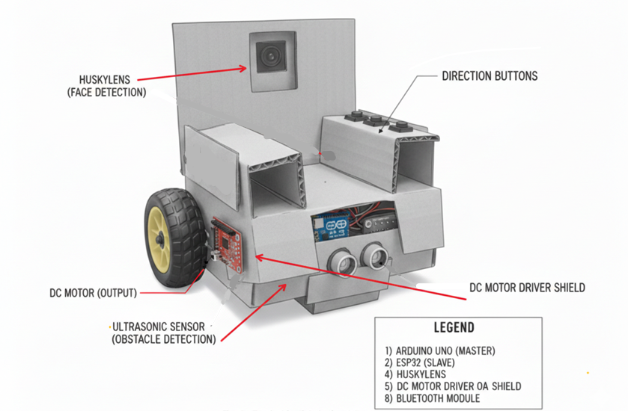

Fig. 5 the prototype of the product (Gemini)

## **3. RESULT AND DISCUSSION**

### **3.1 Face Recognition (HUSKYLENS) Result**

At system startup, the wheelchair remains in a locked state until a trained face is detected by the HUSKYLENS module. During testing, the face recognition system successfully detected registered faces and unlocked the wheelchair only once per startup cycle, as programmed. Once unlocked, the system did not require repeated face detection, preventing unnecessary interruptions during operation.

The system remained locked when:

* No face was detected
* An untrained face appeared
* The camera view was obstructed

This behavior confirms that the face recognition module effectively functions as a security mechanism, ensuring that only authorized users can operate the wheelchair.

This behavior demonstrates that the face recognition system effectively functions as a one-time security checkpoint, preventing unauthorized use while avoiding unnecessary interruptions during movement. However, it was observed that recognition accuracy may decrease under poor lighting conditions or when the user’s face is partially obstructed. Despite this limitation, the system successfully fulfilled its intended role as a security feature.

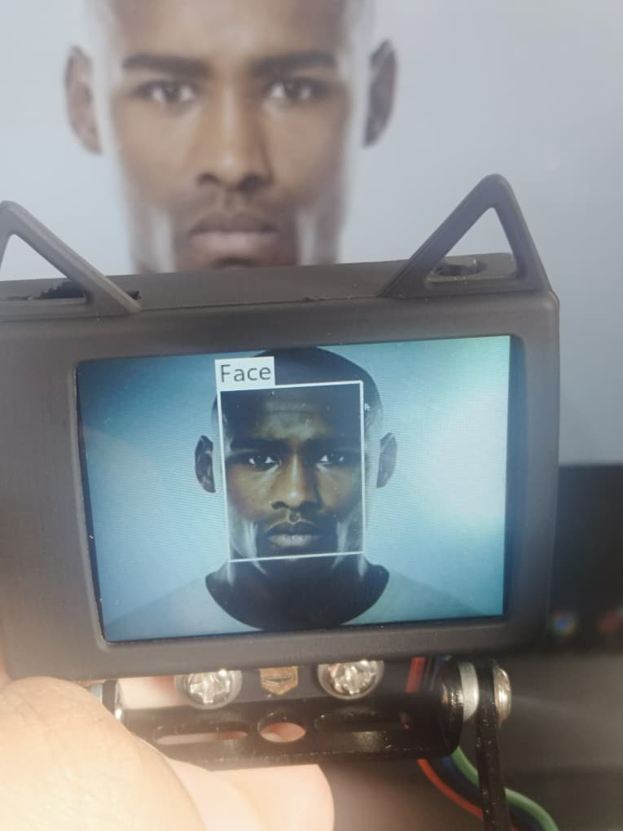

Fig. 6 When there is unregistered face detected

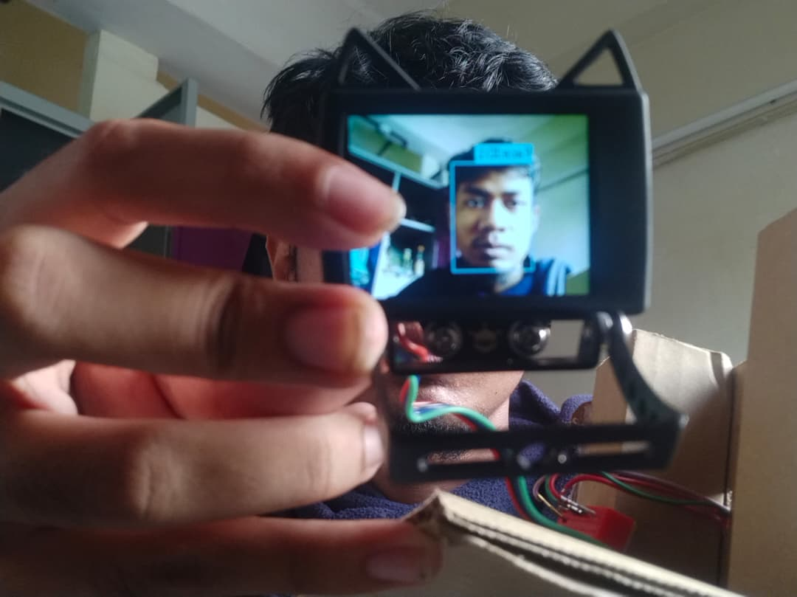

Fig. 7 When the face is registered

**5.2 Ultrasonic Obstacle Detection and Safety Response**

The ultrasonic sensor continuously monitored the distance between the wheelchair and obstacles in front of it. When an obstacle was detected within the predefined safety distance (≤ 60 cm), the system immediately stopped the motors to prevent collision. Once the obstacle was removed, the wheelchair resumed normal operation.

This result confirms that the ultrasonic sensor provides effective real-time obstacle avoidance, significantly enhancing user safety. However, ultrasonic sensing can be affected by object shape and surface material, which may lead to inaccurate distance readings in certain scenarios. Despite this, the system demonstrated consistent and reliable performance during testing.

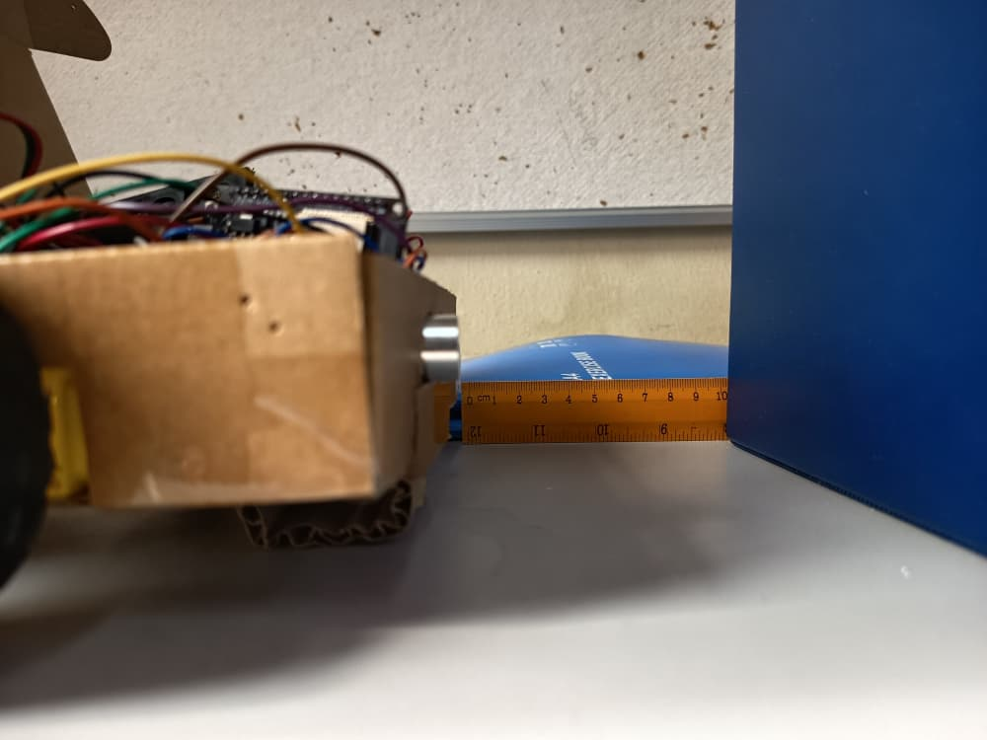

Fig. 8 Obstacle 10 cm away

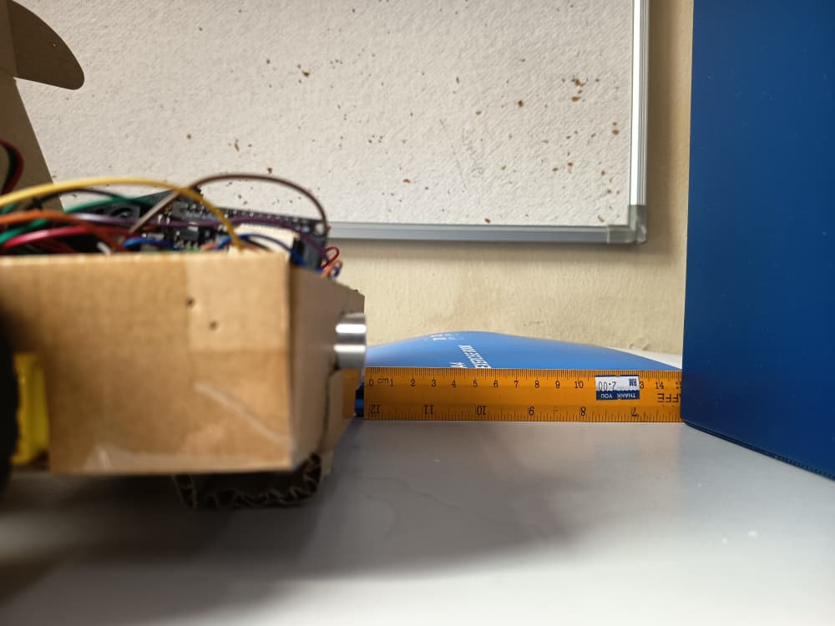

Fig. 9 Obstacle 15 cm away

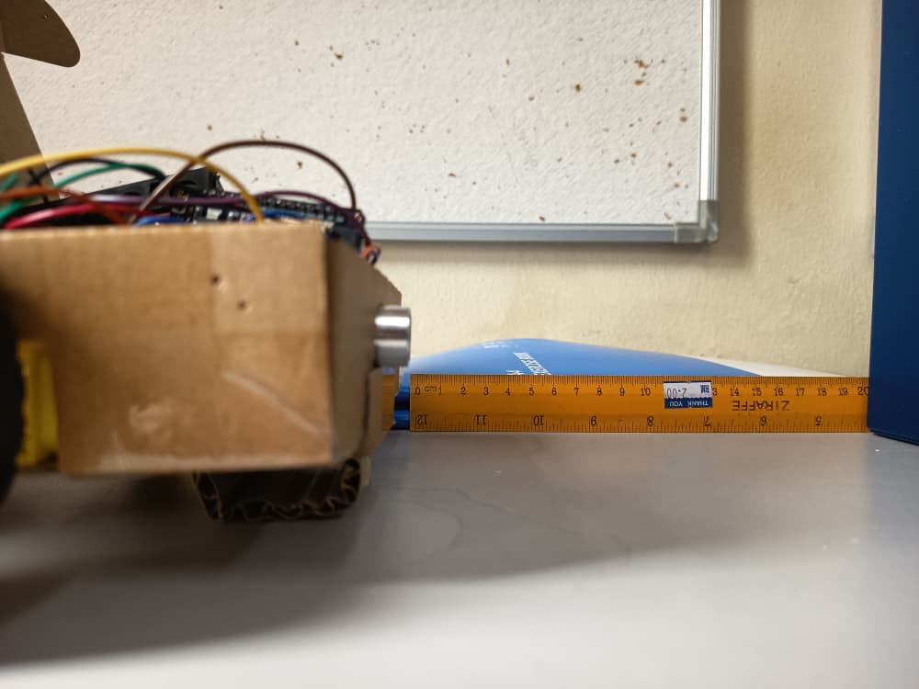

Fig. 10 Obstacle 20 cm away

**5.3 Manual Button Control and Navigation Accuracy**

Four push buttons were used to control the wheelchair’s movement:

* Forward
* Backward
* Turn Left
* Turn Right

After successful face recognition and in the absence of obstacles, each button correctly transmitted movement commands from the Arduino (master) to the ESP32 (slave). The wheelchair responded accurately to each command, and the motors stopped immediately when no button was pressed.

The wheelchair responded accurately to all directional commands and stopped immediately when no button was pressed. This confirms that the button-based navigation system provides precise and responsive control, suitable for users who prefer direct manual operation.

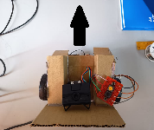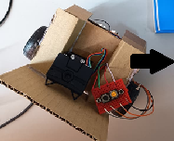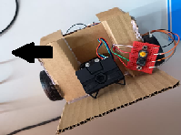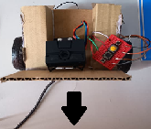

Fig. 11 Forward Fig. 12 Right Fig. 13 Left Fig. 14 Backward

**5.4 Bluetooth Emergency Stop Functionality**

The Bluetooth module on the ESP32 was tested using a smartphone-based Serial Bluetooth Terminal application. When a "STOP" command was sent, the wheelchair immediately halted all motor activity, overriding all other control inputs. Normal operation resumed only after receiving an "ENABLE" command.

This result demonstrates that the Bluetooth emergency stop mechanism operates reliably and has the highest priority in the control hierarchy. This feature is critical for emergency situations, allowing caregivers or users to remotely stop the wheelchair if unsafe conditions arise.



Fig. 15 Serial Bluetooth Terminal App

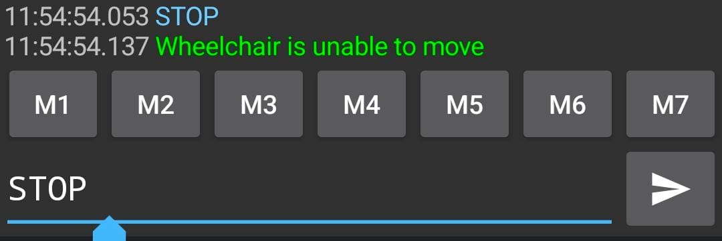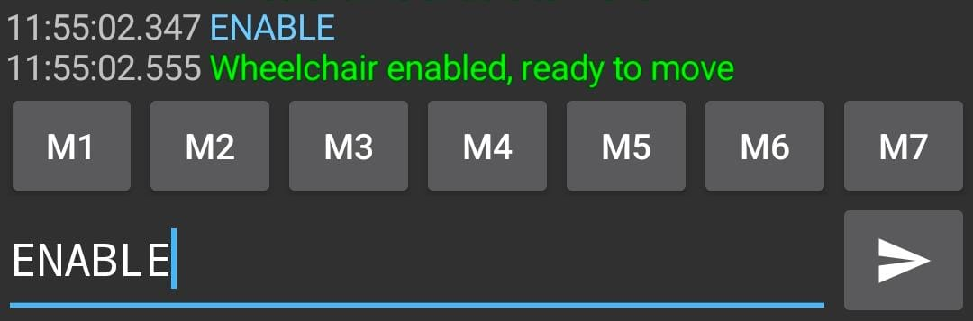

Fig. 16 STOP command Fig. 17 ENABLE command

**5.5 System Integration and Control Architecture Analysis**

The master–slave architecture proved to be an effective system design. The Arduino handled sensor inputs, decision-making, and user commands, while the ESP32 focused on motor execution and Bluetooth communication. This separation of responsibilities reduced system complexity and improved reliability.

Data communication between the two microcontrollers remained stable throughout testing, and no command conflicts were observed. The system responded quickly to changes in sensor data and user input, indicating efficient integration of both hardware and software components.

4. Conclusion

In conclusion, this project successfully demonstrates the development of a smart wheelchair system designed to enhance mobility, safety, and control for individuals with leg impairments. By integrating DC motors, ultrasonic sensing, face detection, and Bluetooth communication within a dual-controller architecture, the system achieves reliable and responsive operation.

The emergency stop feature effectively reduces collision risks by halting movement when obstacles are detected within a predefined safety distance. The implementation of HuskyLens face detection adds an important security layer, ensuring that the wheelchair can only be operated by authorized users. Furthermore, the doctor-controlled Bluetooth activation and deactivation mechanism provides an additional level of supervision, making the system suitable for clinical and rehabilitation environments.

Overall, the project highlights the importance of mechatronics system integration in developing assistive technologies. Future improvements may include speed control, battery health monitoring, GPS tracking, and mobile application integration to further enhance usability and safety. The proposed system serves as a strong foundation for intelligent, medically supervised mobility aids.

**REFERENCES**

1. World Health Organization, *World Report on Disability*, WHO Press, Geneva, Switzerland, 2020. <https://www.who.int/news-room/fact-sheets/detail/disability-and-health>
2. ESPRESSIF Systems, *ESP32 Series Datasheet*, Espressif Systems, 2023. <https://documentation.espressif.com/esp32_datasheet_en.pdf>
3. Arduino, *Arduino Uno Rev3 – Technical Specifications*, Arduino Documentation, 2023. <https://docs.arduino.cc/hardware/uno-rev3/>
4. DFRobot, *HuskyLens AI Vision Sensor User Manual*, DFRobot, 2023. <https://wiki.dfrobot.com/HUSKYLENS_V1.0_SKU_SEN0305_SEN0336>
5. K. Patil, Q. Jawadwala, and F. C. Shu, “Design and construction of electronic aid for physically challenged people,” *IEEE Transactions on Human-Machine Systems*, vol. 48, no. 2, pp. 172–182, 2018. <https://ieeexplore.ieee.org/document/11042637>
6. Prototype setup, Gemini, <https://gemini.google.com/app/91d4805dbf124eaa>
7. L298N motor driver pin connection, <https://lastminuteengineers.com/l298n-dc-stepper-driver-arduino-tutorial/>
8. I2C communication, <https://dronebotworkshop.com/i2c-arduino-arduino/>
9. Coding for slave and master, ChatGPT, <https://chatgpt.com/c/69625f3b-882c-8322-bc65-d96eff73b963>